# Assignment 1: Conceptual Model Design and Business assumptions

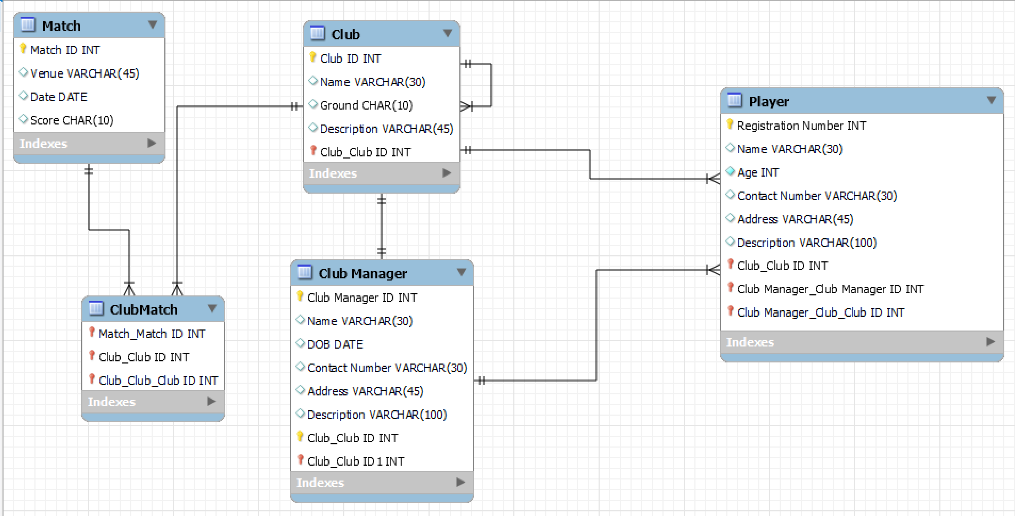

**Business Assumptions:**

1. **The major entities in this conceptual model are Club, Club Manager, Player and Match. There is 1 associative entity called ClubMatch.**
2. **There must be only 1 club manager for each club and the club manager is entitled to manage only 1 club**
3. **Club manager is in charge of buying minimum of 1 player and maximum of many players for the club**
4. **A player can be a part of only 1 club**
5. **The club entity is self-join/unary join as the clubs play amongst themselves (play against each other)**
6. **A club can play minimum of 1 and a maximum of many matches**
7. **A match is played by more than 1 club**